Assignment 3

- When Page loads Display your Full Name and NUID
- Table should not be expanded when page loads
- Submit button to be disabled and grayed out and it should not be clickable
- Add New Student Button should add new student with dummy values and dummy values should be dynamically added e.g for row 4 the values will be Student 4, Teacher 4 etc. and for row 5 the values will be Student 5, Teacher 5 etc
- For newly added rows make sure existing CSS are applied too
- After successful add of the record display the pop-up message with newly added student name in the popup message e.g. if you have added row 4 for student 4 then display “Student 4 Record added successfully” and display error message in case add of record addition failed.

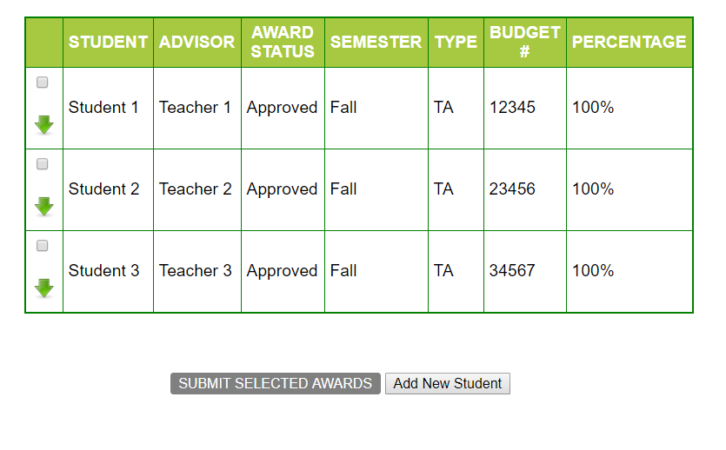
- On Selecting any of the checkboxes,
i] Background color to be changed for the particular row to “Yellow” and
ii] Submit button to turn orange
iii]A delete button should get added dynamically in DELETE column and should delete the entire row when clicked. Also, pop-up message should be displayed by having student name in the popup message e.g. if you have deleted row 4 for student 4 then display “Student 4 Record deleted successfully”
iv) An Edit button should get added dynamically in EDIT COLUMN and should only display pop up box with message e.g. if you are editing student 2 details then edit pop up should display as, title of Edit pop up should be “Edit details of Student 2” and it should display all the fields of student 2 row in the pop up details as text with “Update” and “Cancel” buttons. Data will not be editable as it is text format but when “Update” button is clicked then display “Student 2 data updated successfully” and when “Cancel” button is clicked pop up will be closed
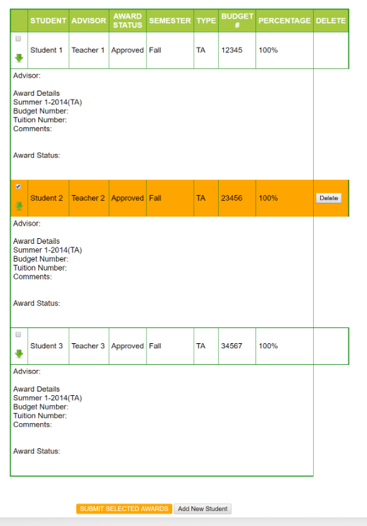
- On Deselecting the checkbox will
- make the row background color white again.
- Also, if none of the rows are selected, the Submit button should be Grayed out again(disabled). (i.e., if 1 or more of the checkboxes are selected, the Submit button will be enabled and background color will be yellow. If none are selected, it will be disabled and background set to Gray)
- DELETE button in those de-selected rows will be hidden
- EDIT button in those de-selected rows will be hidden
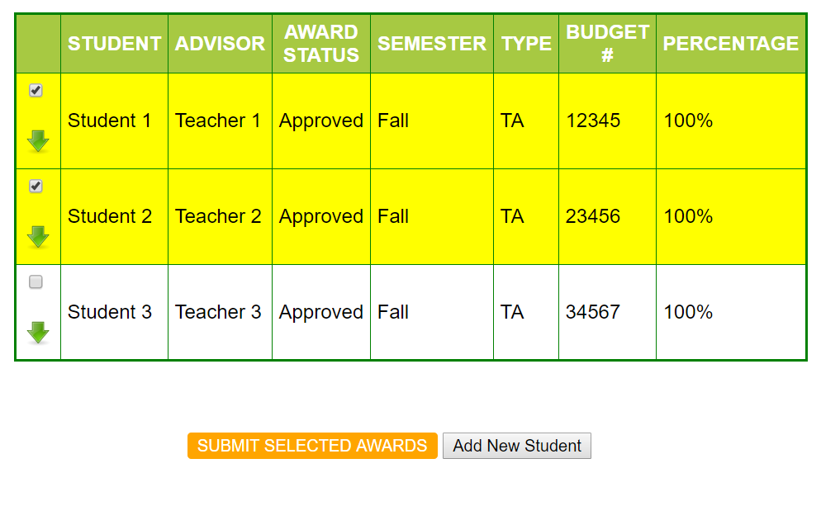

- Clicking on any of the green arrows will expand the particular row. Clicking it again will collapse it (i.e., toggle view on click)

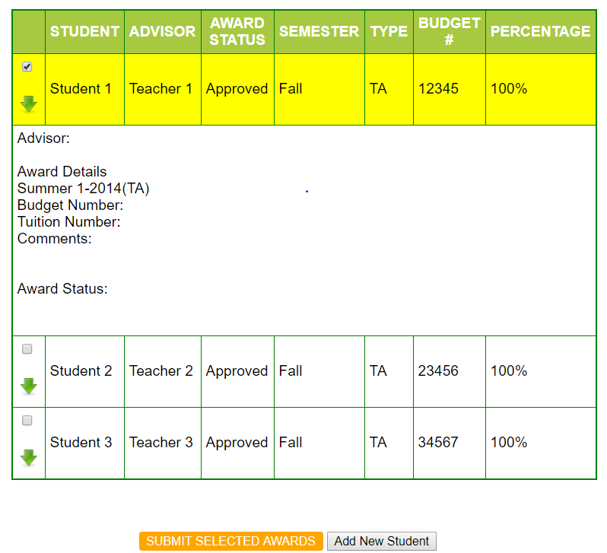

- Assignment must be submitted on your PRIVATE GitHub account (use Northeastern email account) and zip file must be submitted on CANVAS and github URL of assignment in the canvas remarks

